Question:1
Write a C program to print all natural numbers in reverse from n to 1 using for loop
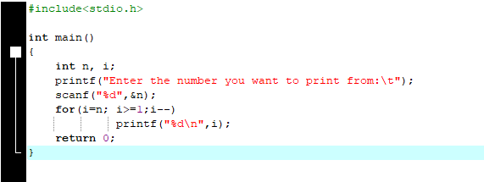
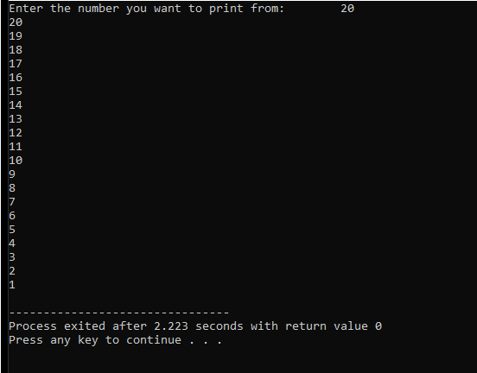

Question:2
Write a C program that user performs multiplication and division without using the * and /
operators:
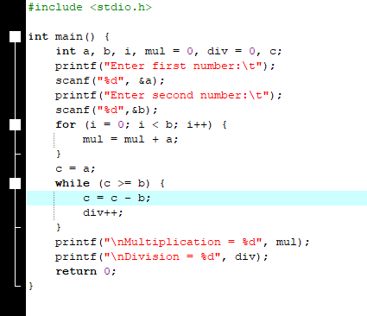
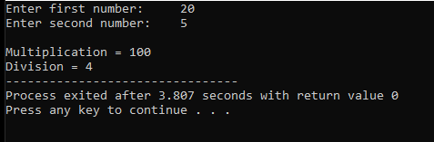

Question:3
Write a C program to input a number and find sum of first and last digit of the number using for
loop.
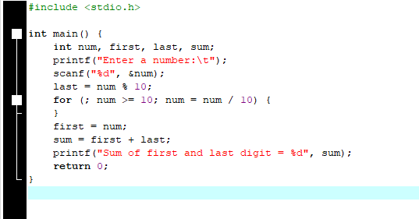
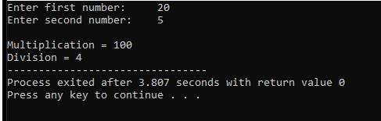

Question:4
Write a C program that takes an integer input from the user and checks whether It is a prime number or not.
A prime number is a natural number greater than 1. That has no positive divisors other than 1 and itself.
Example:
- Input: 17 → Output: "17 is a prime number"
- Input: 15 → Output: "15 is not a prime number"
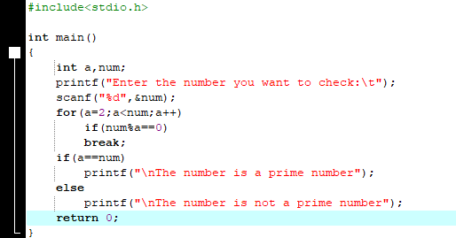
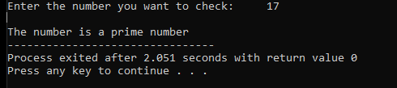
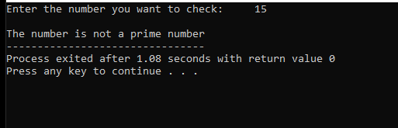

Question:5
Write a C program that asks the user for 10 integer values and counts how many are even and how many are odd.
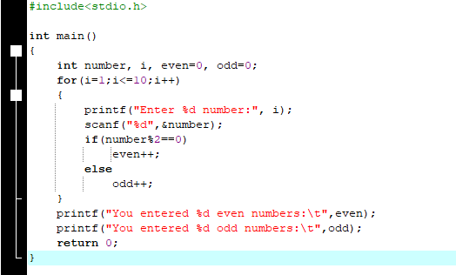
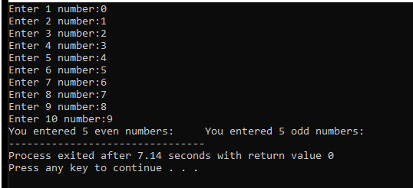

Question: 6
Write a C program that takes an integer input from the user and calculates the sum of its individual digits.
Example:
- Input: 1234 → Output: "Sum of digits: 1+2+3+4 = 10"
- Input: 987 → Output: "Sum of digits: 9+8+7 = 24"
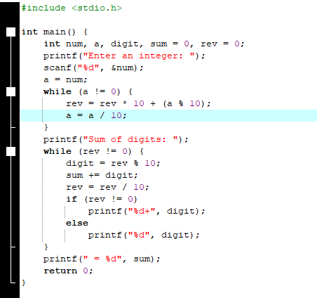
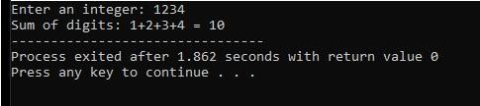
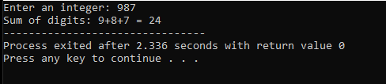
Question:7
Write a C program that takes an integer input from the user and displays the number in reverse order.
Example:
- Input: 12345 → Output: 54321
- Input: 100 → Output: 001.
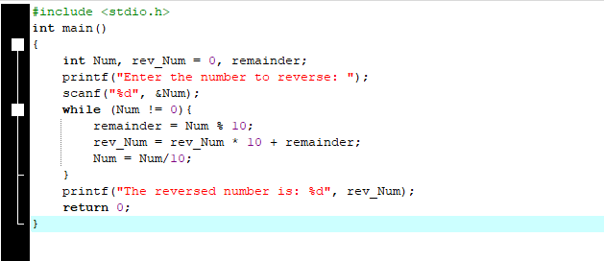
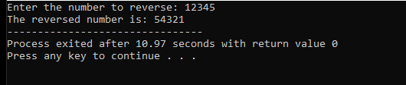
Question:8
Write a C program to check whether a given number is a perfect number. A perfect number is a positive integer that is equal to the sum of its proper positive divisors, excluding the number itself
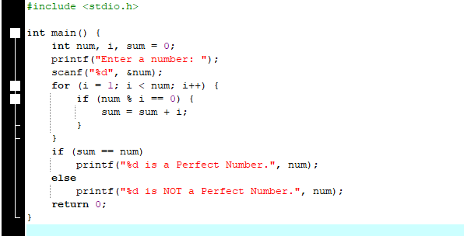
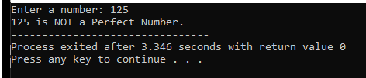
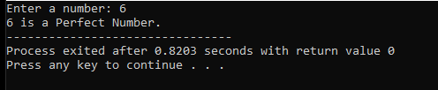
Question:9
Sarah wants to track her monthly expenses more efficiently. She needs a program that can handle multiple expense categories and provide detailed financial analysis
Program Requirements:

- Takes Sarah's monthly income as input
- Collects expenses for 4 categories: Food, Transport, Entertainment, Utilities
- Calculates and displays:
  - Total monthly expenses
  - Remaining balance after expenses
  - Savings amount and what percentage this represents of her income
  - The percentage that each expense category contributes to total expenses
- Provides personalized financial advice:
  - If her savings are more than 20% of income: "Excellent savings!"
  - If any single expense category makes up more than 40% of total expenses: "Warning: High spending in [category]"
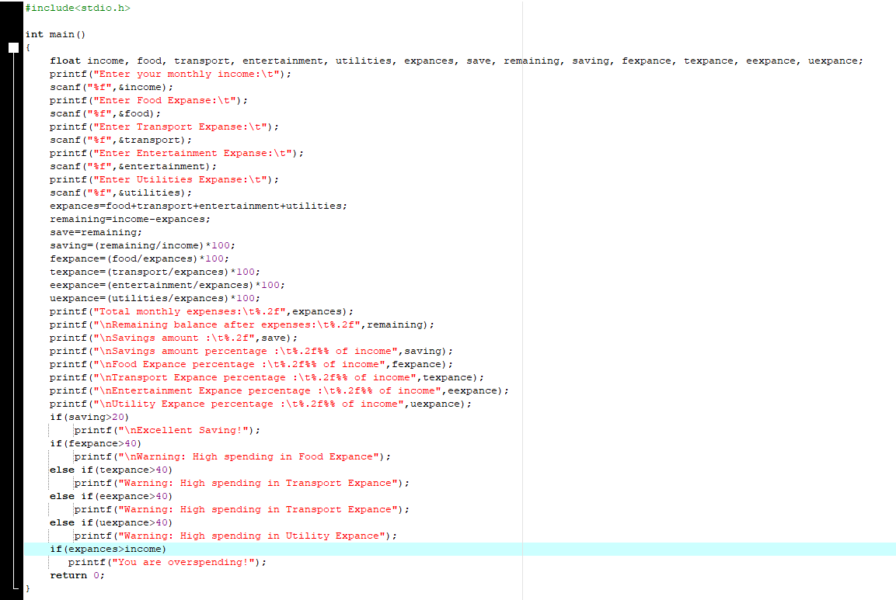
  - If she spends more than her income: "You are overspending!"

